In RAG pipeline, implemented option to user to select the required metrics for evaluation
- Evaluate for all available metrics
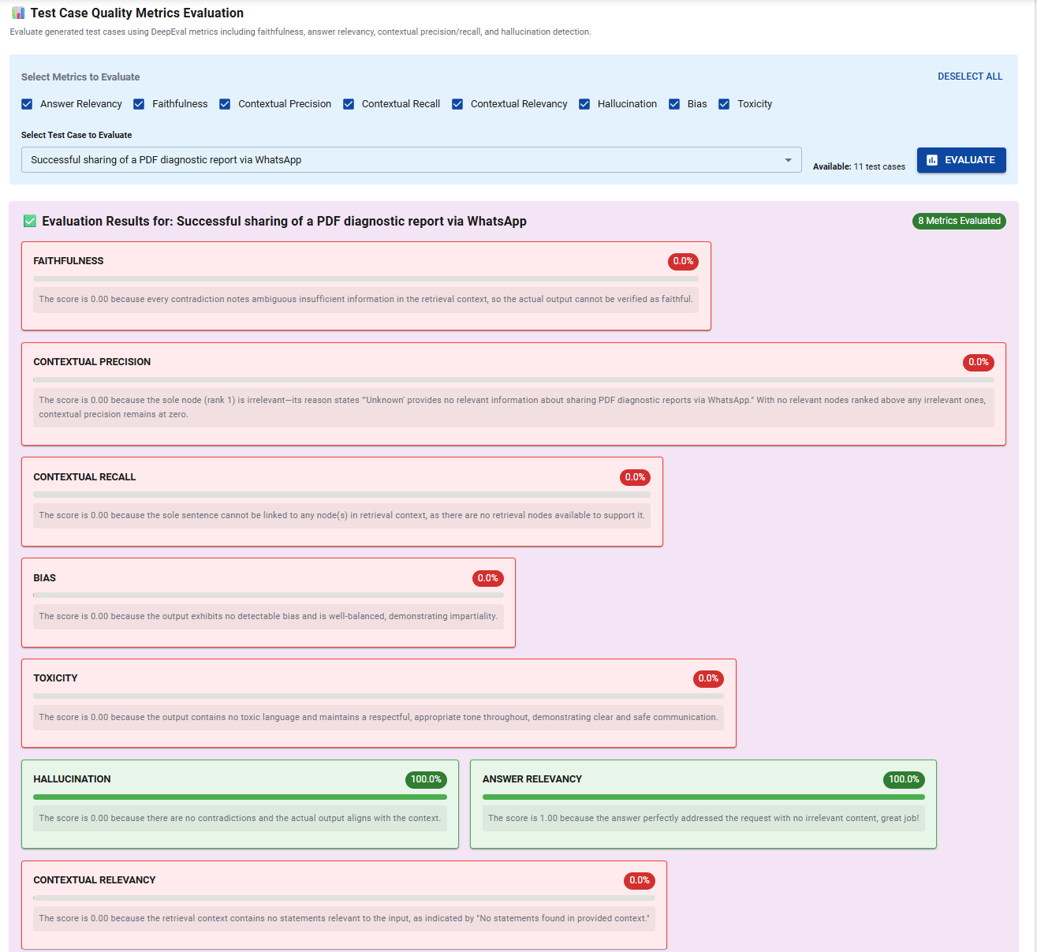
- Evaluate for selected metrics
